Write field here your research topic like biology or Astrophysics



Title of the Article here (Make sure it is concise and covers the topic)

Author Name (Write first and last name), High School Name

Abstract

*Write down here your abstract. The abstract should be a brief summary of the research article of this particular subject and should easily help the reader know the article’s main scope and purpose. The abstract should not be less than 50 words or more than 250.*

1. **Introduction**

Write down your introduction here. The introduction should assert down any **background knowledge** of this topic including what is known about your topic and what is unknown. Why do you think this topic is **significant**? What ideas is it built on? In this section, make sure to use in text citations and a lot of references for your information. **Each in-text citation in this section will be labeled by the number corresponding to its place in the references table below.** For example, pain receptors are known for their importance [1].

1. **Section Heading**

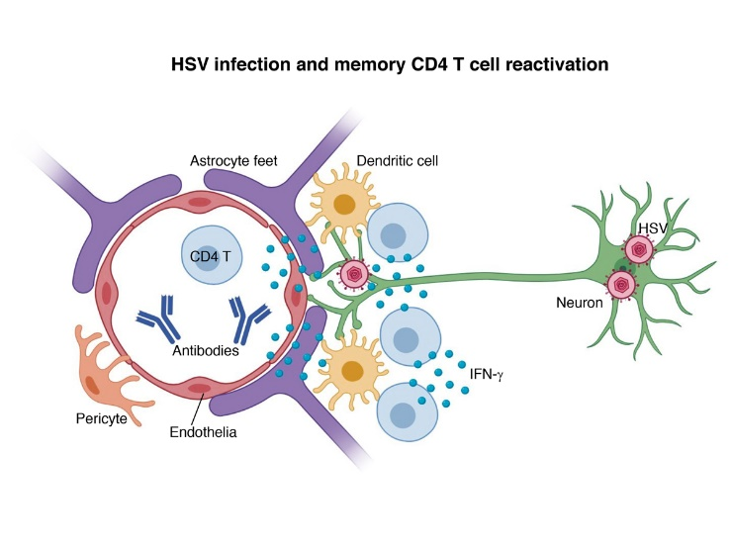

Figure 1: Add caption here.

You can add as many of these sections as you want and label them as you want. These sections will act as your **main body** of the article, where you can discuss the main topics. For example, you could have a section describing a certain researcher’s findings, biological mechanisms or phenomena. Make sure to use **in-text citations** and a lot of references to your claims.

**Each in-text citation in this section will be done by labeling it with the number corresponding to its place in the references table below.** For example, pain receptors are known for their importance [1]. If you want to, you can add figures to your article by following the example: HSV infection affects neural bodies, as shown in figure 1.

1. **Section Heading**

You can add as many of these sections as you want and label them as you want. These sections will act as your **main body** of the article, where you can discuss the main topics. For example, you could have a section describing a certain researcher’s findings, biological mechanisms or phenomena. Make sure to use **in-text citations** and a lot of references to your claims.

**Each in-text citation in this section will be done by labeling it with the number corresponding to its place in the references table below.** For example, pain receptors are known for their importance [1]. If you want to, you can add figures to your article by following the example: HSV infection affects neural bodies, as shown in figure 1.

1. **Section Heading**

If you want to divide your section into even more parts, then you can use this style for it. Remember, this is **optional**. Like this:

1. Example Sub-Section Heading

Then, you can add as many sub-sections as you would like using this style to your article.

1. Example Sub-Section Heading

You can add as many of these sections as you want and label them as you want. These sections will act as your **main body** of the article, where you can discuss the main topics. For example, you could have a section describing a certain researcher’s findings, biological mechanisms or phenomena. Make sure to use **in-text citations** and a lot of references to your claims.

1. Example Sub-Section Heading

You can add as many of these sections as you want and label them as you want. These sections will act as your **main body** of the article, where you can discuss the main topics. For example, you could have a section describing a certain researcher’s findings, biological mechanisms or phenomena. Make sure to use **in-text citations** and a lot of references to your claims.

1. Example Sub-Section Heading

You can add as many of these sections as you want and label them as you want. These sections will act as your **main body** of the article, where you can discuss the main topics. For example, you could have a section describing a certain researcher’s findings, biological mechanisms or phenomena. Make sure to use **in-text citations** and a lot of references to your claims.

1. **Conclusion**

This is the last part of the main body of the review article. Here, you’d summarize all the topics brought up in this review article like the abstract, but also conclude all the topics that was mentioned throughout the whole articles in this section.

1. **References**
2. Use IEEE citation style to cite your references here.
3. For example : J. Alonso, M. Petukhova, G. Vilagut, S. Chatterji, S. Heeringa, T. Ustun and A. Alhamzaw, "Days out of role due to common physical and mental conditions: results from the WHO World Mental Health Surveys," Molecular Psychiatry, pp. 1-13, 2010.
4. Use IEEE citation style to cite your references here.
5. Use IEEE citation style to cite your references here.
6. Use IEEE citation style to cite your references here.
7. Use IEEE citation style to cite your references here.